**Curriculum Vitae**

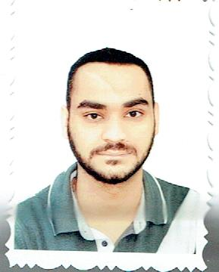**Name** : MUSTAFA SALAH SALMAN

**Address** : Baghdad – Alwazieriya

**Mobile** : 00964 (6491218)

**E mail**: [mustafa_alhafidh@yahoo.com](mailto:mustafa_alhafidh@yahoo.com)

**Date of Birth** : September 22th, 1988

**Gender** : Male

**Nationality :** Iraqi

**Marital status :** Single

**Scientific qualification:**

B.Sc. information technology from University of Teaching information of management, on the academic year 2010 – 2011.

**Objective:**

To obtain a job in the field of computer in which in which my technical skills organization abilities, human relations skills, and work experience will be utilized to **Languages:**

* Arabic
* English

**Skills :**

* Microsoft office program (Word , Power point, Excel, Access)
* I have a degree in Galileo used in Travel & Tourism Co.'s

**Courses and Vocations:**

* Administrative Officer, Advisory Office, Faculty of Engineering, Mustansiriya University
* Pharmaceutical Sales Representative at Huawei Pharmaceutical Co. (Baghdad - Bab Al Sharqi)
* Pharmaceutical Sales Representative in the Hayat Technology Company (Baghdad - Waziriya)